**BANK LOAN ANALYSIS REPORT - QUERY DOCUMENT**

1. **BANK LOAN REPORT | SUMMARY**

**KPI’s**

**1.a. Total Loan Application**

SELECT

COUNT(id) as Total_loan_applications

FROM bank_loan

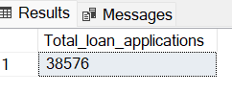

**b. MTD Loan Applications**

SELECT

COUNT(id) as MTD_Total_loan_applications

FROM bank_loan

WHERE MONTH(issue_date) = 12

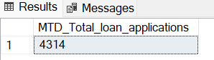

**c. PMTD**

SELECT

COUNT(id) as PMTD_Total_loan_applications

FROM bank_loan

WHERE MONTH(issue_date) = 11

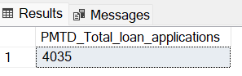

**d.** **MOM expressed as a percentage.**

SELECT

ROUND(

100 * (

CAST((SELECT COUNT(id) FROM bank_loan WHERE MONTH(issue_date) = 12) AS FLOAT) -

CAST((SELECT COUNT(id) FROM bank_loan WHERE MONTH(issue_date) = 11) AS FLOAT))/

CAST((SELECT COUNT(id) FROM bank_loan WHERE MONTH(issue_date) = 11) AS FLOAT),

1

) AS PCT_change

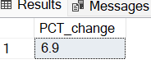

**2.a.** **Total Funded Amount**

SELECT

SUM(loan_amount) as Total_funded_amt

FROM bank_loan

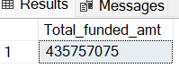

**b.** **MTD Total Funded Amount**

SELECT

SUM(loan_amount) as MTD_total_funded_amt

FROM bank_loan

WHERE MONTH(issue_date) = 12

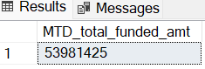

**c. PMTD Total Funded Amount**

SELECT

SUM(loan_amount) as PMTD_total_funded_amt

FROM bank_loan

WHERE MONTH(issue_date) = 11

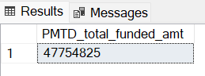

**d. MoM on Total Funded Amount**

SELECT

ROUND(

100*(

CAST((SELECT SUM(loan_amount) FROM bank_loan WHERE MONTH(issue_date) = 12) AS FLOAT)-

CAST((SELECT SUM(loan_amount) FROM bank_loan WHERE MONTH(issue_date) = 11) AS FLOAT))/

CAST((SELECT SUM(loan_amount) FROM bank_loan WHERE MONTH(issue_date) = 11) AS FLOAT), 2)

AS Pct_change

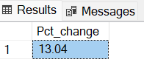

**3.a. Total Amount Received/Collected**

SELECT

SUM(total_payment) as Total_amt_received

FROM bank_loan

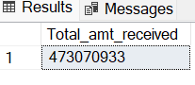

**b. MTD Total Amount Collected**

SELECT

SUM(total_payment) as MTD_total_amt_collected

FROM bank_loan

WHERE MONTH(issue_date) = 12

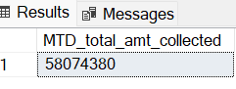

**c. PMTD Total Amount Collected**

SELECT

SUM(total_payment) as PMTD_total_amt_collected

FROM bank_loan

WHERE MONTH(issue_date) = 11

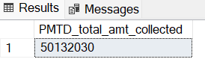

**d. MoM on Total Amount Collected**

SELECT

ROUND(

100*(

CAST((SELECT SUM(total_payment) FROM bank_loan WHERE MONTH(issue_date) = 12) AS FLOAT)-

CAST((SELECT SUM(total_payment) FROM bank_loan WHERE MONTH(issue_date) = 11) AS FLOAT))/

CAST((SELECT SUM(total_payment) FROM bank_loan WHERE MONTH(issue_date) = 11) AS FLOAT), 1)

AS MoM_change

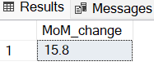

**4.a. Average Interest Rate**

SELECT

ROUND(AVG(int_rate) * 100, 2) as Avg_int_rate

FROM bank_loan

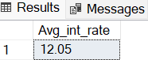

**b. MTD Avg Interest Rate**

SELECT

ROUND(AVG(int_rate) * 100, 2) as MTD_Avg_Interest_rate

FROM bank_loan

WHERE MONTH(issue_date) = 12

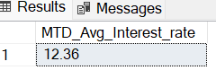

**c. PMTD Average Interest Rate**

SELECT

ROUND(AVG(int_rate) * 100, 2) as PMTD_Avg_Interest_Rate

FROM bank_loan

WHERE MONTH(issue_date) = 11

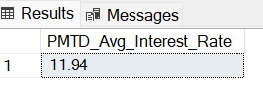

**d. MoM on Avg Interest Rate**

SELECT

ROUND(

100 *(

CAST((SELECT (AVG(int_rate) * 100) FROM bank_loan WHERE MONTH(issue_date) = 12) AS FLOAT)-

CAST((SELECT (AVG(int_rate) * 100) FROM bank_loan WHERE MONTH(issue_date) = 11) AS FLOAT))/

CAST((SELECT (AVG(int_rate) * 100) FROM bank_loan WHERE MONTH(issue_date) = 11) AS FLOAT), 1)

AS pct_change

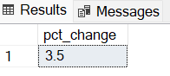

**5.a. Average Debt-to-Income Ratio (DTI)**

SELECT

ROUND(AVG(dti) * 100, 2) as Avg_dti

FROM bank_loan

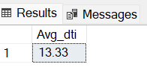

**b. MTD dti**

SELECT

ROUND(AVG(dti) * 100, 2) as Avg_MTD_DTI

FROM bank_loan

WHERE MONTH(issue_date) = 12

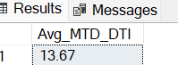

**c.PMTD DTI**

SELECT

ROUND(AVG(dti) * 100, 2) as Avg_PMTD_DTI

FROM bank_loan

WHERE MONTH(issue_date) = 11

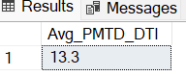

**C. MoM on DTI**

SELECT

ROUND(

100 *(

CAST((SELECT (AVG(dti) * 100) FROM bank_loan WHERE MONTH(issue_date) = 12) AS FLOAT)-

CAST((SELECT (AVG(dti) * 100) FROM bank_loan WHERE MONTH(issue_date) = 11) AS FLOAT))/

CAST((SELECT (AVG(dti) * 100) FROM bank_loan WHERE MONTH(issue_date) = 11) AS FLOAT), 1)

AS pct_change

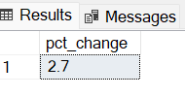

**GOOD LOAN VS BAD LOAN KPI’S**

**1.GOOD LOAN**

**a.Good Loan issued**

SELECT

loan_status,

CASE

WHEN loan_status = 'Charged Off' THEN 'BadLoan'

ELSE 'GoodLoan'

END AS Loan_Classification

FROM bank_loan

ALTER TABLE bank_loan

ADD Loan_Classification Varchar(20)

UPDATE bank_loan

SET Loan_Classification =

(

CASE

WHEN loan_status = 'Charged Off' THEN 'BadLoan'

ELSE 'GoodLoan'

END

)

SELECT

COUNT(Loan_Classification) as Good_Loan_issued

FROM bank_loan

WHERE Loan_Classification = 'GoodLoan'

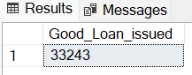

**b. Percentage of Total Good Loan Applications**

SELECT

ROUND(

100 *

CAST((SELECT COUNT(Loan_Classification) as Good_Loan_applications FROM bank_loan WHERE Loan_Classification = 'GoodLoan') AS FLOAT)/

CAST((SELECT COUNT(id) as Total_loan_applications FROM bank_loan) AS FLOAT), 1)

as pct

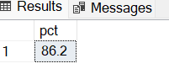

**c. Good Loan Funded amount**

SELECT

SUM(loan_amount) as GoodLoan_Funded_amt

FROM bank_loan

WHERE Loan_Classification = 'GoodLoan'

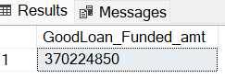

**d. Good Loan Total Received Amount**

SELECT

SUM(total_payment) as GoodLoan_amt_rcvd

FROM bank_loan

WHERE Loan_Classification = 'GoodLoan'

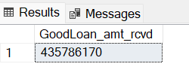

**1.BAD LOAN**

**a. Bad Loan issued**

SELECT

COUNT(Loan_Classification) as Bad_Loan_issued

FROM bank_loan

WHERE Loan_Classification = 'BadLoan'

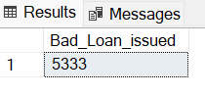

**b. Percentage of Total Bad Loan Applications**

SELECT

ROUND(

100 *

CAST((SELECT COUNT(Loan_Classification) as Good_Loan_applications FROM bank_loan WHERE Loan_Classification = 'BadLoan') AS FLOAT)/

CAST((SELECT COUNT(id) as Total_loan_applications FROM bank_loan) AS FLOAT), 1)

as pct

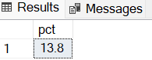

**c. Bad Loan Funded amount**

SELECT

SUM(loan_amount) as BadLoan_Funded_amt

FROM bank_loan

WHERE Loan_Classification = 'BadLoan'

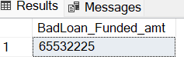

**d. Bad Loan Total Received Amount**

SELECT

SUM(total_payment) as BadLoan_amt_rcvd

FROM bank_loan

WHERE Loan_Classification = 'BadLoan'

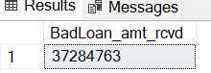

**LOAN STATUS GRID VIEW.**

SELECT

loan_status,

COUNT(id) AS Total_Applications,

SUM(total_payment) AS Total_Amount_Received,

SUM(loan_amount) AS Total_Funded_Amount,

AVG(int_rate * 100) AS Interest_Rate,

AVG(dti * 100) AS DTI

FROM bank_loan

GROUP BY loan_status

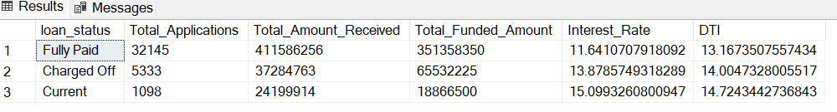

SELECT

loan_status,

SUM(total_payment) AS MTD_Total_Amount_Received,

SUM(loan_amount) AS MTD_Total_Funded_Amount

FROM bank_loan

WHERE MONTH(issue_date) = 12

GROUP BY loan_status

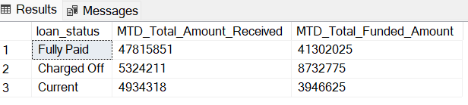

1. **BANK LOAN REPORT | OVERVIEW**

**MONTH**

SELECT

MONTH(issue_date) as Month_number,

DATENAME(MONTH, issue_date) as Month_Name,

COUNT(id) as Total_Applications,

SUM(loan_amount) as Total_funded_amt,

SUM(total_payment) as Total_pmt_received

FROM bank_loan

GROUP BY MONTH(issue_date), DATENAME(MONTH, issue_date)

ORDER BY 1,2

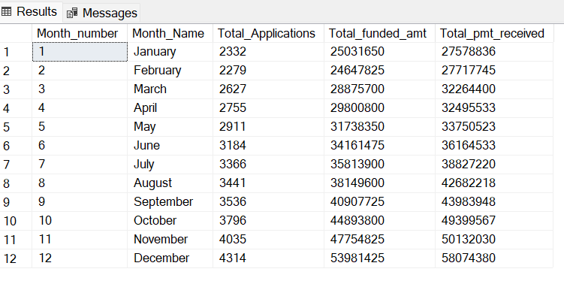

**STATE**

SELECT

address_state,

COUNT(id) as Total_Applications,

SUM(loan_amount) as Total_funded_amt,

SUM(total_payment) as Total_pmt_received

FROM bank_loan

GROUP BY address_state

ORDER BY 1

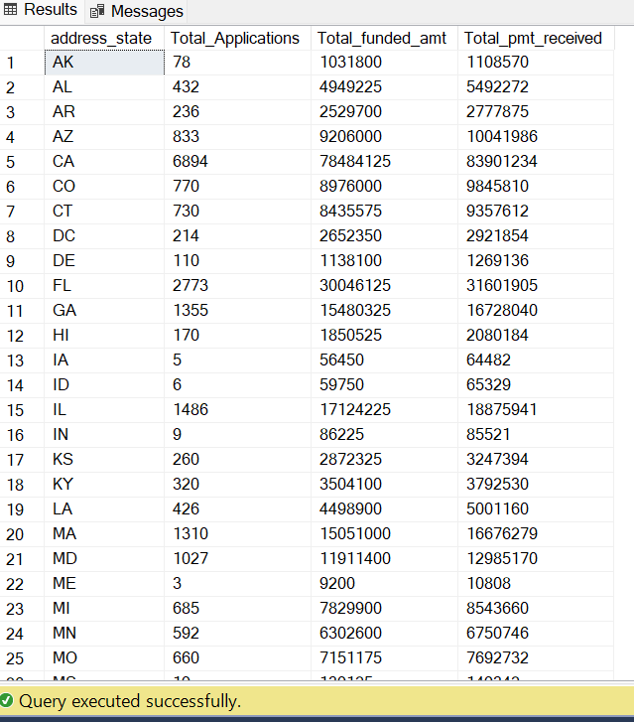

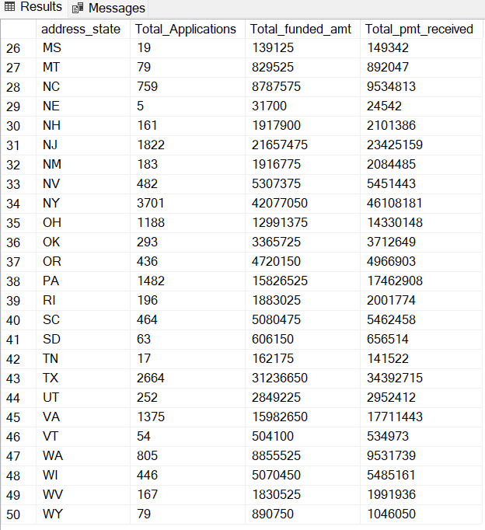

**TERM**

SELECT

term,

COUNT(id) as Total_Applications,

SUM(loan_amount) as Total_funded_amt,

SUM(total_payment) as Total_pmt_received

FROM bank_loan

GROUP BY term

ORDER BY 1

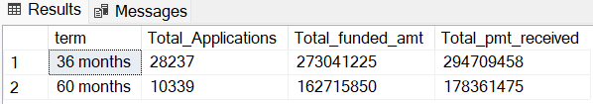

**EMPLOYMENT LENGTH**

SELECT

emp_length,

COUNT(id) as Total_Applications,

SUM(loan_amount) as Total_funded_amt,

SUM(total_payment) as Total_pmt_received

FROM bank_loan

GROUP BY emp_length

ORDER BY 1

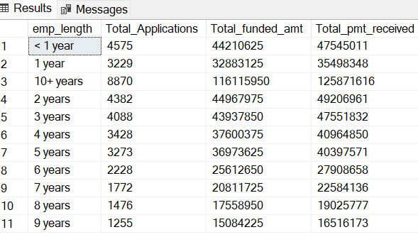

**PURPOSE**

SELECT

purpose,

COUNT(id) as Total_Applications,

SUM(loan_amount) as Total_funded_amt,

SUM(total_payment) as Total_pmt_received

FROM bank_loan

GROUP BY purpose

ORDER BY 1

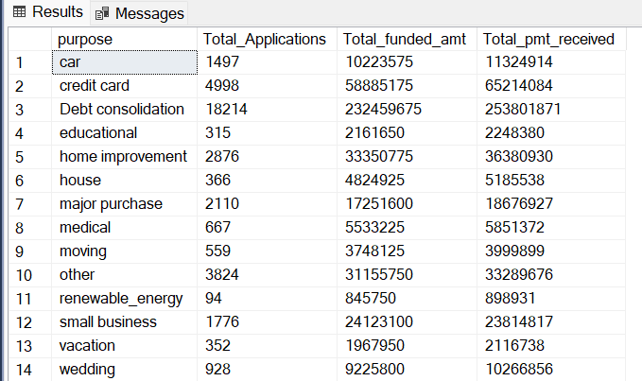

**HOME OWNERSHIP**

SELECT

home_ownership,

COUNT(id) as Total_Applications,

SUM(loan_amount) as Total_funded_amt,

SUM(total_payment) as Total_pmt_received

FROM bank_loan

GROUP BY home_ownership

ORDER BY 1

